- As explained before, owners of storage facilities can choose to inject or withdraw gas depending not only on future market prices, but also on past decisions and physical constraints. After they make this decision they decide also on the amount of gas they will apply this decision to.
- Resolving the question what are withdrawal decisions tuned to ? comes down to resolving two questions:
  - 1. When are the storages withdrawing or injecting gas ?
  - 2. What volume of gas is involved in this decision ?
- Answering the first question is equivalent to resolving a binomial classification problem where the possible answers are:
  - 1, pass: we are withdrawing and so net withdrawals are positive
  - 0, fail: we are injecting and so net withdrawals are negative or equal to 0
- As for the second question, it is a regression problem that will be resolved by using an OLS linear regression on the variables we will choose.

Understanding the Model:

- We will consider time spreads as regressors. A spread is basically a difference in prices. A time spread is a difference in prices between two products at two different time horizons. In our model we will take the spreads of the season ahead product - the day ahead product.
- Since our storages are impacted by 4 markets (TTF, NCG, NBP and GSPL) we will take the time spreads of these markets.
- As for the physical constraints, we will consider percentage of full stock projected for the day t and net withdrawals of day t - 1. Percentage of full stock is the volume of gas in the storage (the working gas volume in GWh) divided by the maximum storage capacity of the storage (in GWh)
- We will only consider instances where net withdrawal (NW = withdrawal - injection) is positive
- Since withdrawal/injection capacities behavior changes as a function of stock levels, we will study one cases of cut–off, 45% for withdrawal. So the column of full stock will be replaced by two columns of full stock FSW1 and FSW2.
  - FSW1 = max(Full Stock - 45, 0)
  - FSW2 = max(45 - Full Stock, 0)
- The following chart will make it easier to understand the use of the model.

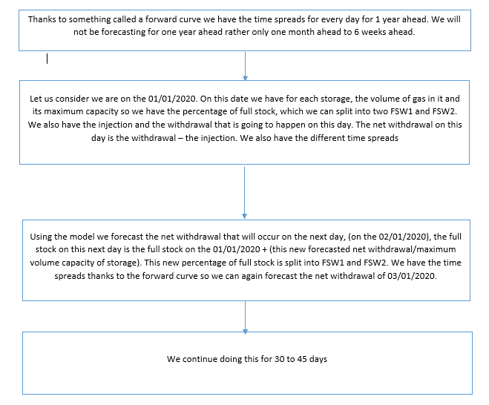
Building the Model:

- You will need to import the storage data from the storage_data.xlsx. Each sheet has data for a storage. The sheet name is the storage name. Each sheet looks like this.

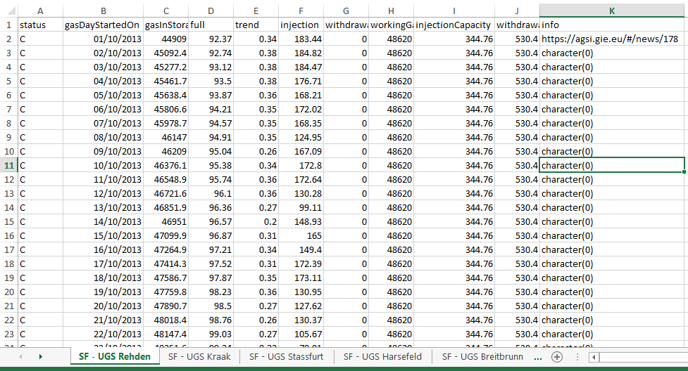
- This excel has already been adjusted so use it as is.
  - The excel sheet should be opened in a dictionary variable here each key is the sheet name and each item is a DataFrame representing the storage data.
  - The relevant columns for us at this point are full this is the %full stock injection and withdrawal. The workingGasVolume column is the maximum volume capacity of the storage. This will be useful for us in the last forecasting stage, not now necessarily.
  - Calculate a net withdrawal column (-injection + withdrawal).
  - Create a new Lagged_NW column this will symbolize the NW of the day prior
  - Create a new Net Withdrawal column named Net Withdrawal_binary with 0 where NW is <=0 and 1 when NW > 0
  - Split the full column into two columns FSW1 and FSW2
  - Select the gasdaystartedon, net withdrawal, net withdrawal lagged, net withdrawal_binary, FSW1 and FSW2 columns

- Import now the price_data.csv file it has 4 columns
  - Change the name of the Date column to gasDayStartedon (just like the name in the storage_data.xlsx)
  - The other columns represent the time spread columns

Part 1: Classification

- Create 2 empty dictionaries to put in the results of the two classification models. Each item of these dictionaries are dictionaries of metrics
- Now you have to create a for loop on the dictionary of storage data. For each storage in the dictionary inner_join (using dfply) it on date with the price DataFrame, this makes sure your rows are coherent. If you have trouble with this part tell me so that I can help you directly I do not want you to waste time on this.
- Use the following link as help to create the logistic regression:
  - https://towardsdatascience.com/logistic-regression-python-7c451928efee
  - Your y array is the Net Withdrawal_binary column
  - Your X matrix is composed of the Lagged_NW, FSW1, FSW2 and all the time spreads price columns
- After having fit your logistic regression save the metrics in a dictionary and then save that dictionary to the initial results dictionary
  - Your metric dictionary should look as follows, where cm is the confusion matrix:
d = {'recall': metrics.recall_score(y_test, y_pred), 'neg_recall': cm[1,1]/(cm[0,1] + cm[1,1]), 'confusion': cm, 'precision': metrics.precision_score(y_test, y_pred), 'neg_precision':cm[1,1]/cm.sum(axis=1)[1], 'roc': metrics.roc_auc_score(y_test, probs),
‘class_mod’: the logistic regression}

- Do this for the random forest as well. Use this link to help you:
https://towardsdatascience.com/an-implementation-and-explanation-of-the-random-forest-in-python-77bf308a9b76
- Choose the best classification model for this particular storage between both by comparing all the metrics (except the confusion matrix). Create a function to do this
- Lastly find which classification model works best over all storages by counting for how many storages is the logistic regression/the random forest better and choosing the one that fits most storages better

Part 2: Regression

- Create 1 empty dictionary to put in the results of the regression model. Each item of this dictionary is a dictionary of metrics
- For each storage in the storage dictionary choose only the rows where Net Withdrawal_binary is = 1 (where we have withdrawal)
- Using the following link as help conduct the multidimensional linear regression: https://towardsdatascience.com/a-beginners-guide-to-linear-regression-in-python-with-scikit-learn-83a8f7ae2b4f
  - Your X matrix is composed of the Lagged_NW, FSW1, FSW2 and all the time spreads columns
  - Your y vector is the Net Withdrawal column
- After having fit your regression save the metrics in a dictionary and then save that dictionary to the initial results dictionary. The metrics dictionary should look as follows:
d = {'r2': metrics.r2_score(y_test, y_pred), 'rmse': rmse, 'nrmse': nrmse, 'anrmse': anrmse, 'cor': corr, 'l_reg': the regression}

Part 3: Retrieve your models:

After having chosen a classification model and having run a multi-dimensional linear regression, save the results dictionary of the chosen classification model and the one of the multi-dimensional linear regression into a pickle file to be able to use them in the last step, the balance step.

model = {'regression': d_regression, 'classification': d_classification_chosen}
import pickle
filename = 'finalized_model.sav'
pickle.dump(model, open(filename, 'wb'))

Part 4: Comparing to Benchmark Model

- This part is not obligatory but you will some extra points if you manage to do this
- Create a benchmark model which is based on only a multidimensional regression (with the negative net withdrawals not being removed)
- Compare the metrics of this model with the metrics of our model
- You need to put part 1 and part 2 together to be able to do this. This means that you need to run the best classification model and then use the coefficients of the regression when this classification model returns the number 1

